Microsoft Excel

**Microsoft Excel** is a [spreadsheet](https://en.wikipedia.org/wiki/Spreadsheet) developed by [Microsoft](https://en.wikipedia.org/wiki/Microsoft) for [Windows](https://en.wikipedia.org/wiki/Microsoft_Windows), [macOS](https://en.wikipedia.org/wiki/MacOS" \o "MacOS), [Android](https://en.wikipedia.org/wiki/Android_(operating_system)) and [iOS](https://en.wikipedia.org/wiki/IOS" \o "IOS). It features calculation, graphing tools, [pivot tables](https://en.wikipedia.org/wiki/Pivot_table), and a [macro](https://en.wikipedia.org/wiki/Macro_(computer_science)) programming language called [Visual Basic for Applications](https://en.wikipedia.org/wiki/Visual_Basic_for_Applications). It has been a very widely applied spreadsheet for these platforms, especially since version 5 in 1993, and it has replaced [Lotus 1-2-3](https://en.wikipedia.org/wiki/Lotus_1-2-3) as the industry standard for spreadsheets. Excel forms part of the [Microsoft Office](https://en.wikipedia.org/wiki/Microsoft_Office) suite of software.

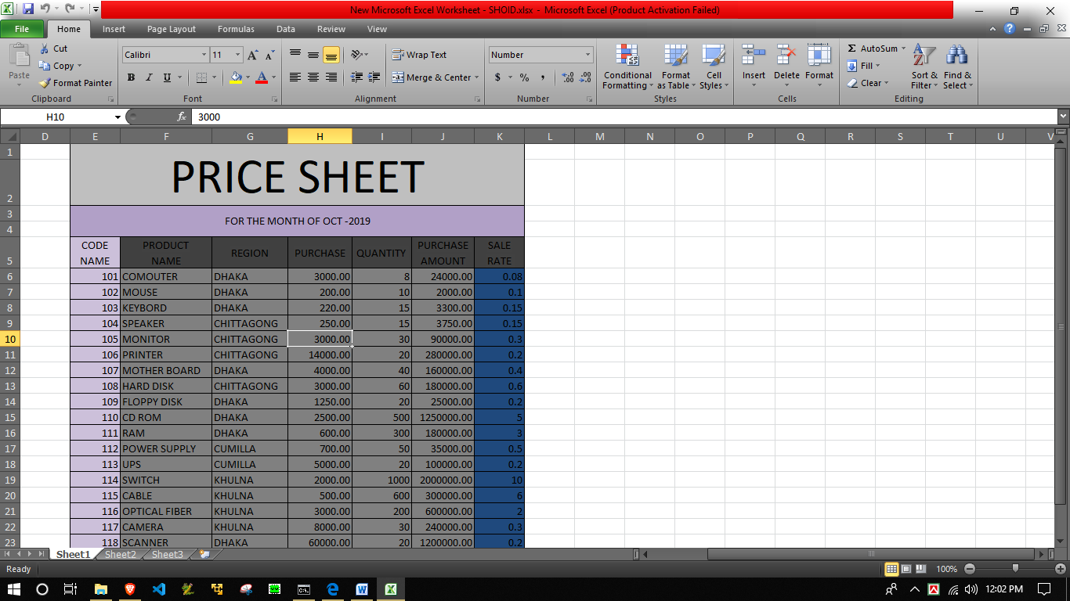

Now it's time to get enough ideas about Excel. Now we can see some examples of Excel.

  
What appears above is a calculation sheet created by Excel